ARCHISHA SINHA

R054

MBA Tech AI

**Recommendation System**

**Lab 1**

**Case Study on Netflix Recommendation Systems**

Netflix's recommendation system is a key part of their business, helping users discover new content and keeping them engaged with the platform. The recommendation system is a big data project that has evolved as Netflix has transitioned from a DVD rental service to a global streaming platform.

Netflix is a widely loved streaming service, and it owes much of its popularity to its personalized content suggestions. Netflix employs artificial intelligence to keep an track of what each user watches, what they like and what they rate highly. Then based on this information, it suggests other shows and movies that users are likely to find interesting.

**What is recommender system?**

It refers to a kind of system that could predict the future preference of users based on their previous behavior or by focusing on similar users behaviour.in a nutshell, recommender systems are like salespeople who knows us (our likings and dislikings) very well and suggest products that would attract us the most.

**What are the types of recommender system?**

There are majorly six types of recommender systems which work primarily in the Media and Entertainment industry:

1) Collaborative Recommender system

2) Content-based recommender system

3) Demographic based recommender system

4) Utility based recommender system

5) Knowledge based recommender system

6) Hybrid recommender system.

**The Netflix Recommendation Engine**

Their most successful algorithm, Netflix Recommendation Engine (NRE), is made up of algorithms which filter content based on each individual user profile. The engine filters over 3,000 titles at a time using 1,300 recommendation clusters based on user preferences.

It’s so accurate that 80% of Netflix viewer activity is driven by personalized recommendations from the engine. It’s estimated that the NRE saves Netflix over $1 billion per year. It’s so accurate that 80% of Netflix viewer activity is driven by personalized recommendations.

**How does Netflix use a recommendation system?**

Recommendation algorithms are at the core of the Netflix product. They provide our members with personalized suggestions to reduce the amount of time and frustration to find something great content to watch.

**How does AI of Netflix’s Recommendation System work?**

* It tracks what you watch, how long you watch it, and whether you finish it.
* Then figure out what kinds of shows and movies you are into, like genres, theme, and actors you prefer.
* Then it rates each show and movies based on the factors like popularity, user ratings, and how well they match your taste.
* Netflix then uses this information to create a custom list of recommendations just for you.

In simple terms, Netflix AI keeps getting smarter as you watch more content. It learns from your choices and becomes better at suggesting shows and movies that you’ll like.

Netflix uses, Collaborative filtering as it relies on the concept that people who liked something in the past would also like the same experience in the future.

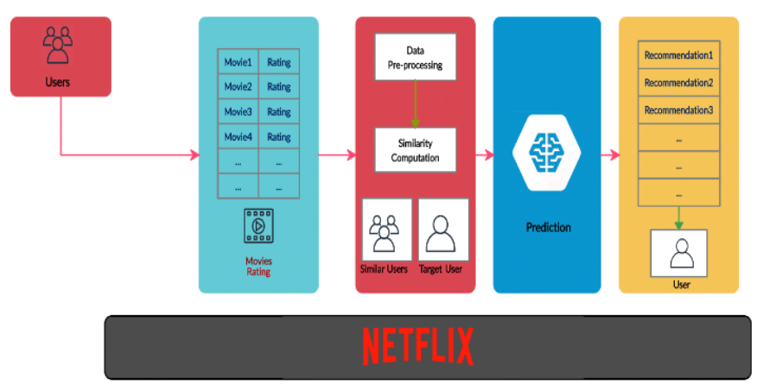

**Two key limitations of collaborative filtering recommendation systems are**

1. ***Cold Start Problem***

* New users who have not yet provided any ratings or feedback pose a challenge for collaborative filtering systems.
* Without any user behavior data to analyze, it is difficult for the system to make accurate recommendations for these new users.
* The same problem occurs when adding new items to the system that have not yet been rated or interacted with by users.

1. ***Sparsity***

* As the number of users and items grows, the user-item interaction matrix used by collaborative filtering becomes increasingly sparse.
* Most users only rate or interact with a small fraction of the total items available.
* This data sparsity makes it difficult to find similar users with overlapping preferences to base recommendations on.
* It also makes it challenging to find correlations between niche items that have few interactions.

**How does missing value affect the UI matrix in collaborative filtering in recommendation system?**

Missing values in the user-item matrix significantly affect collaborative filtering (CF) systems, particularly in recommendation algorithms. The presence of these missing values can lead to challenges in accurately predicting user preferences and item relevance.

The impacts of it are:

1. Sparsity of the User-Item Matrix: When many values are missing, the algorithms may struggle to identify meaningful patterns or similarities among users and items.
2. Assumptions of Missing Data: If the missingness is related to the unobserved ratings themselves (non-random missingness), it can skew the model's learning and degrade performance.
3. Prediction Techniques: To address missing values, various imputation strategies are employed before applying matrix factorization techniques like Singular Value Decomposition (SVD).

**NETFLIX PRIZE**

The Netflix Prize was a significant competition launched by Netflix in October 2006, aimed at improving the accuracy of its recommendation system, ‘*Cinematch’*. The challenge invited data scientists and machine learning experts to develop algorithms that could predict user ratings for films more accurately than Netflix's existing system. The goal was to reduce the root mean squared error (RMSE) of the predicted ratings by at least 10%, from an initial RMSE of 0.9525 to below 0.8572. A prize of $1 million was offered to the team that could achieve this benchmark.

Participants were provided with a dataset containing over 100 million ratings from approximately 480,000 users for nearly 18,000 movies. The ratings were anonymous, and the competition included a training set, a qualifying set, and a test set to evaluate the submitted algorithms.

In 2007, a team known as ***Korbell*** won the first Progress Prize by achieving an ***8.43%*** improvement over the baseline, using a combination of 107 algorithms, including Matrix Factorization (SVD) and Restricted Boltzmann Machines (RBM) to reach an RMSE of 0.88. This achievement demonstrated the effectiveness of ensemble methods in improving predictive accuracy. The grand prize was ultimately awarded on September 21, 2009, to the team BellKor's Pragmatic Chaos, which surpassed the required benchmark by achieving an RMSE of 0.8567.

This team has used many complex algorithms and then ensembled them by blending them well and thus resulting in decline in their loss by 8.43%. Their success highlighted the potential of collaborative filtering and advanced machine-learning techniques in recommendation systems.